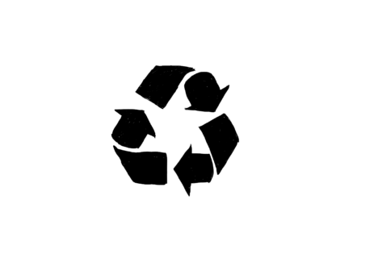
Recyclable Plastic Types
Not all plastic can be recycled. 80% can.

There are many different types of plastic and they can not be recycled together. This means it is important to identify the different types to be able to separate them. This easy guide can help identify these different types.

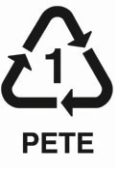
Often on the underside of the plastic item you will sees triangle sign and a number inside. This tells you which kind of plastic it is. Sometimes it doesn't have this mark, but this guide will help you.

(Polyethylene terephthalate) Usually clear in colour, called ‘one use’ plastic. Water, soda, fruit juice, cooking oil plastic bottles. Not the bottle tops.

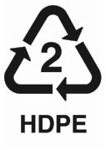

(High-density polyethylene) Very hard wearing, doesn't break down easily in the all weathers. Milk jugs, detergents, shampoo, shower gels and juice bottles, butter tubs, waste bins and toiletries containers.

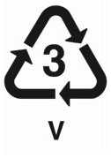

PVC (Polyvinyl Chloride) It is a soft, flexible plastic. It’s quite toxic and continues to be throughout it’s life.
Clear plastic food wrapping, sweet, fruit wrapping. Cooking oil bottles, teething rings, children’s and pets’ toys, and blister packaging.
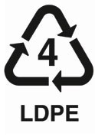

(Low-density polyethylene) Is very soft plastic. Shopping bags, shrink wrap, dry cleaner garment bags and squeezable or crushable bottles.
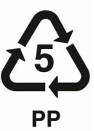

(Polypropylene) It is tough and durable. Disposable diapers, pails, plastic bottle tops, margarine and yogurt containers, potato chip bags, straws, packing tape and rope. Also yogurt pots, medicine and ketchup bottles, kitchenware and “microwave-safe” plastic containers.
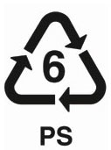

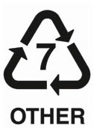
(Polystyrene, or Styrofoam or Unicel) It is structurally weak and ultra-lightweight, it breaks up easily and is dispersed readily throughout the natural environment. Beaches all over the world have bits of polystyrene on the shores. It takes hundreds of years to decompose. Disposable food containers. Also foam packing, CD cases & jewellery.

"everything else" and is composed of any new plastics, including bioplastics, and could also be comprised of different types of plastics such as acrylic, nylon, fibre glass.

